Summary of Requirements:

1. Put logistics functionality in a single location
   1. Currently working on Rig board, Bulk Plant, Crew Mgmt & Job Board
   2. Want to do more on the Job Board
      1. Assign crews from the job board
         1. Select product from left side of bulker job board, select crew, select assign (similar to pumper page)
      2. Urgency is determined by:
         1. Job Date/Time
         2. On location data/time
   3. Want all jobs to show up on the job board
      1. Jobs not flagged as need haul, still need to show up
   4. Logistics decides go with crew
2. Simplify Bulk Plant Page – modify to icons and blend requests page
3. ~~Change NW (Norman Wells) to NWT – is this still required? Done~~
4. Haul Blend call sheets available & rules
5. More room for notes on the Job Board – How can we use Icons?
   1. Create more room
   2. Bring people and unit notes at surface
6. ~~Rig bin to Rig bin (from 1 location to another)~~
   1. ~~Can do backhaul. Does this work?~~
7. Raw Product - Vendor to BP
   1. This is the ordering app
      1. What do I need in the BP
      2. When do I need it
      3. What did I receive
      4. View of trucks moving product
   2. Ultimately track all bulk products and modify AX with PO’s etc
      1. Will take a couple steps….
8. ~~Raw Product - BP to BP~~
   1. ~~Can use haul/backhaul from bulk plant board. Does this work?~~
9. Off duty timer – fix – Colin will talk to Shawn
   1. Is this still an issue? Need to clarify rules.
10. Bin Flush – part of BPAVS
    1. What are the business rules? Meeting Aug 1 to discuss the rules
    2. Is it requested? – Automatic based on rules
    3. When? What is used? How much? Black job?
    4. Flag where?
11. Job Board Planned Units – separate today and tomorrow
    1. Can we change the planned colour? Icon?
    2. Different label?
       1. Show “Planned” - today
       2. Show “Planned TMRW” – not today but tomorrow
          1. Put TMRW in Yellow or Gold Colour
12. Add Expected Time on Location to Job Board
    1. Would like to use – when will it be loaded and ready then calculate the rest add travel time to get on location time.
    2. Load time for BP – when does it need to be loaded?
       1. Better default time?
    3. On location time – calculate when we need to leave the bulk plant?
       1. ~~Better default value?~~
       2. Calculated value
    4. Add validation to schedule product haul so that we are not changing the order
13. Evercrete – move through the system
    1. This is blended using a different method. Used infrequently so do not need to add the method to our system. Would like to see the trucks hauling.
    2. How is this blended if it doesn’t go through BPAVS?
    3. Add button to move blend to completed (Bulk Plant Board)
14. Project loads – truck movement and cement tonnages
    1. Will have the MTS in the Product haul page
    2. Add ability to the job board
    3. Add MTS button to rig bins
15. Tracking cement on pad locations
    1. Add icons for project BP’s show tonnages and blends
16. Repurposing/reblending Cement
17. Chem Vans – simple tracking of movement
    1. This is the ordering app…
    2. What do we really want to see?
18. Visibility of spare units in the district
    1. This is at the Job Board, truck is broke down, how do I find a replacement easily
    2. Right now it seems trucks are not in the right place. Estevan doesn’t have as many trucks as are listed
19. Modify offload instructions after the bulker En Route
    1. Focus is get to location and it needs to go to a different bin
       1. Can we update at the job board then update eService and the rest of the system
       2. Logistics does the update
    2. Destination focus: Review and update…
    3. When changing to on location, should we review details and modify then?
       1. Update time, bin etc?
    4. Driver focus: Reschedule and send MTS? Reprint and email?
    5. Want to stay on the job board page
    6. Allow to be rescheduled and reprinted / email
20. Report actual offload after the bulker On Location
21. ~~Back haul not shown on Job Board is a known DRB bug - Done~~
22. Bulker status enhancement
    1. As long as we have blend request, we can handle
23. Product haul cancellations/changes after it is Loaded – same as #19
    1. Cancel haul and offload
    2. Need to think about how to keep bulker as storage
24. Crew Management – “Lock” assigned crews
25. Alerts for incoming blending (Short Notice) – GITHUB 206
26. Pop up Bin Load History – similar to #15
    1. Show in and out
27. Future Desires:

* Would like to do most of the functionality in a single place – Job board is the preference
* Feeling like we are bouncing around to different pages to do different items.
  + Makes it feel complicated

1. Bulk plant page

* Would like this page to be reworked. It is too busy and complicated
* Do not need to see the scheduled blends
* Do not want to move blends to the bin – do this automatically
* Once a blend is completed please move it to the bin
  + Have some logic to make sure that the bin is empty
  + If product is in there, stop the process and deal with product in the bin
* **Current Bulk Plant Page - GP:**

* + **Desired Bulk Plant Page - GP:**

* This is Colin’s desire, but it loses the view of conflicts if exists. E.g. there was 0:1:0 ‘G’ left in the bin from previous request. We are going to load ECOPrime from the next request, we want to avoid over topping by mistake. We will need to show what is currently in the bin and what is going to be loaded.
  + **Can the view be of just the bin**
  + **Have a calendar icon (or other icon) to have a popup showing upcoming scheduled blends**
* When we provide API for BPAVS, it will stop BPAVS loading to a bin if a different blend is in the Bin.

I would propose as following.

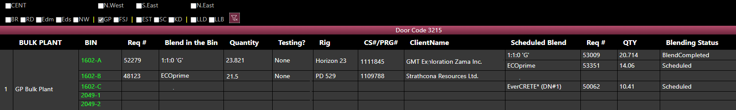

* + Only show completed blends and have them put into the bin right away
    - Continue to show all the associated information for the blend in the bin
  + I think you guys captured my feedback and requirements pretty well. I see there is still some concern about scheduled blends. Again, I do not see this as an issue: we can treat this the same ways as bins on location. We should get an error message if trying to add one blend to a different blend. I see no need for scheduled blends anywhere.
  + On mock up “Desired Bulk Plant Page – GP” I notice that there are still 2 call sheets/rigs/clients assigned to 1602-A. If this is because the product in there is the same blend but used for both rigs (ie 10 tonne blended for GMT and 13.821 blended for Birchliff, or 10 tonne blended for GMT and 13.821 backhauled from Birchcliff) then this is OK, in fact it is ideal. Or is there some other reason why there are 2 call sheets listed?

All silos and bulker with show as an icon with brief information, mouse over will show detail information. All current context menu will stay.

1. NW is Norman Wells. This commonly mistaken for N. West.
   * Would like to change NW to NWT to make sure that these are not mixed up
2. Haul Blend – options for different call sheet…

* Currently call sheets are available that match the base blend
  + Concerns that this could cause an error if people are not paying attention and select only the first call sheet in the list
  + View above will keep call sheet #’s visible
* If call sheet which the blend request was originated is not complete, keep the same call sheet.
* If call sheet is complete, manually enter
  + Have validation on exact blend match (blend + dry blended additives)
* I like the solution you came up with for call sheet numbers, this rule makes sense to me
* Priority here is to help the cement blend move through the Haul process with the added step of being stored and tested prior to hauling.
  + “Count” the load in BI-87
  + Future considerations for this is how it ties into the complexity matrix workflow.
  + Need discussion on the matrix workflow ….. hauling was independent of the workflow – discussed that we may haul prior to having approval, approval is for job execution.

1. Notes (DRB - Bulker Job Board)

* Need larger area for more notes
* Currently Use Notes for:
  + Non rig haul
  + Raw product
  + Convoy only – notes about the driver or truck
    - Class 5 only
  + Resting
  + Resetting
  + Save for another job
  + Current workaround for convoy only driver, or any notes that need to “stick with” a person or unit is to go to the Resource Board and enter the notes that way. Lots of scrolling and time consuming.
  + These notes are only visible if we “expand” the crew on the job board (things can get missed easily)
  + Need to find a way to identify convoy only drivers
  + Once “non-rig haul”, raw product, etc use cases are complete we wont need to put these in the notes.
  + Biggest issue is planning notes: which hotel is the crew staying at, any special instructions for the next shift, etc.
  + Here is a starting point:

* + Would like the notes specific to the people or equipment to show up in this area as well
  + Other items to do
    - Can also use short name for company
    - Remove (Day) from the data – show date only
    - Shrink Status and dropdown (smaller font if needed)
    - Hide 3rd haul, or other options
  + This will create even more space

1. Rig Bin to Rig Bin – can do back haul. Is this good enough?
2. Raw product haul

* Vendor to BP
* BP to BP
* Want 2 options with clean view
  + Right click on bulk plant
    - Time
    - Vendor
    - Product – Colin will provide product list to see how we can filter
    - Crew
    - PO
    - Other
* Do we need to go to the bulk plant tab for this? (just thinking about minimizing page changes)
* Is the PO required? Is this being considered for future integration with AX? Or just as a unique trip identifier?
* How will the trips be tracked in BI-087 (will there be a load ID?)
* Right click on Bulk Plant on the Bulk Plant page:

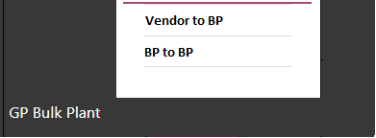

* When clicking on “Vendor to BP”

* BP to BP

1. Off duty timer not working when a haul is pending
   1. It should be integration issue. In latest version of DRB, DRB only sends status change request to eServiceOnline, eServiceOnline side may not reset the timer properly.
2. **Bin Flush**
   1. **How to properly deal with this**
   2. **Who does this? Is this BPAVS only?**
   3. Bin Flush – I think this should be managed in BPAVS, it will NOT be requested from the dispatcher through the DRB.
3. Planned Units:
   1. I noticed today on the job board that there were some duplicate units. Michael Raymond on unit 870011 is one example, though there are a few on here. I have been trying to be on my team to make sure ONLY units that we are using are planned and to unplan any units that we aren’t using (if we change crew, unit, etc).
   2. A screenshot of a computer

      Description automatically generated
   3. Alex pointed out that the managers in RD had put it in the schedule this way, and that the Bulker schedule page was correct but the crew planned for tomorrow was showing up today as planned. As you can see below, Mike and Evan are planned on the truck together today, then Mike is solo for the weekend, then Evan is back on Monday. So everything is done correctly on the district and Logistics side, but the Truck board is showing the unit in duplicate.

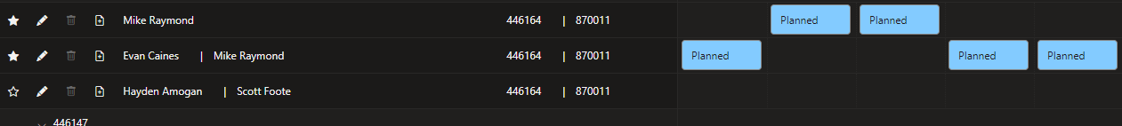

* 1. This is troublesome for a couple reasons:
     1. If we are trying to audit the dispatchers for compliance in using the tool properly, it is frustrating because sometimes it could be that we have duplicate units scheduled, and sometimes it could be just that tomorrow’s unit is showing up.
     2. Having a bunch of unusable units on the page makes things too busy, we don’t know which one to use without bouncing back and forth between pages.
* Potential solutions
* Identify if a unit is planned for tomorrow
* Have the units show up in a different section if they are planned for tomorrow or a different day.
* Don’t have the units show up at all, unit the day they are planned.
  + - **The job board has a 48 hr view which could have the same unit on the board 2 times if one is scheduled for today and one for tomorrow.**
    - **Is there a way to differentiate the units planned for today vs tomorrow?**
      * **Have today’s units at the top, tomorrow at the bottom. If they are the same they stay at the top.**
      * **Have different shading of background color to differentiate between today and tomorrow**
        + **Units at the top for today or today and tomorrow will be dark**
        + **Units at the bottom for tomorrow to be a “dark grey” shading. Just enough to be different from the black background.**

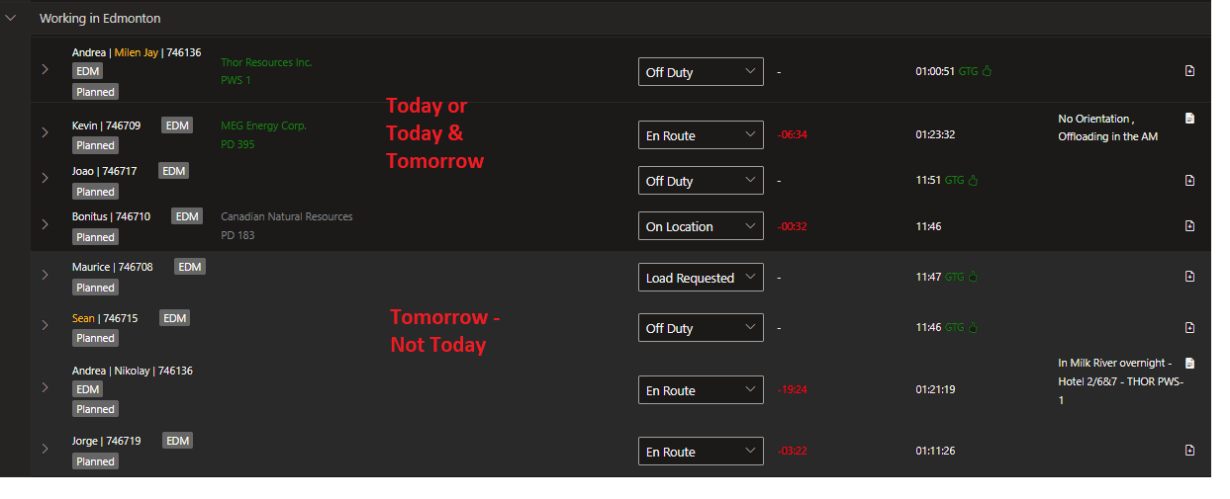

* Duplicate Planned units Units
  + Plan to have “tomorrow’s” units at the bottom with a different shading is sufficient.
  + That was we can send the blend request the night before. This is a good solution.

1. Add Expected time on location to Job Board

* I still need to dig into this a bit more. I would expect that Estimated loading time is important until status changes to “loaded” and then expected on location time becomes relevant.
  + Expected on location time might change based on expected load time. For example if we plan on loading Andrea at 08:00 and her expected on location time is 12:00, but then something at the bulk plant causes her not to be loaded until 13:00, then expected on location time would be 17:00.
* For the hauls, which time dictates the schedule? – Expected On Location Time
* A screenshot of a computer

  Description automatically generated
* When looking at the “On Location” what time is in the window?
* 
  + The first time is Expected Load time
  + The second time is expected on location time
* Is there another place where the time can be put so that it is seen?
  + Team is putting the first load as first best guess
  + Then the 2nd they are putting out 10+ hrs, but often this is still messing with the time of the first one and changing the order creating more work.
  + If they could easily see the time they will keep things straight
  + They don’t feel that this time is important and view it really as 1st, 2nd, 3rd etc
  + On the Job Board,
    - Change the company name to “Short Name” (Create more space)
    - Add Expected location time so that it is immediately known

* Need to confirm with logistics what time they feel is more important - Expected location time
* Go with crew and delay will need to update the time on the job board
  + Still show on location time, which is aligned with callsheet.
  + If job is postponed and call sheet updated, the time will need automatically update

1. Evercrete doesn’t go through BPAVS

* Need a different way to deal with this so it can be tracked
* EverCrete doesn’t go through BPAVS
* We need to either have BPAVS program alternative blending rules for certain blends
* To assign a load to something blended outside of BPAVS, we may treat the same as projects (see below)
* Not sure what the last note means?
* How do we get this blend to move through the bulk plant page as it never gets to a blended stage and then sits and stays on the bulk plant page making it messy

1. Project Loads

* Currently, we can haul cement TO a project (or remote bulk plant such as Kindersley)
* Need to iron out the process to haul FROM project to a rig
  + Can we generate MTS without having the bulk plant as a middleman
  + Can we assign the haul to a current call sheet instead of having to fill out the long form Schedule product haul?
* Option on rig to haul from project/storage?
* Currently the crew just pulls the load out of storage, logistics has very little to do with this, and so we want to make sure it is super simple.
* Crew might load a full truck, and then use for multiple jobs.
* For the job board, can we identify if units are in the projects? Almost like a separate district or how we specify project rigs on the rig board. (NOTE: the project rig function is not being used this year, I need to find out from Brett why not)

1. Tracking cement on pad locations (SAGD, batch surfaces)

* Will need to review the current sheets with you guys to make sure we are meeting all requirements
* Currently there is a low level of trust in how this function works
* BI cement tracking?
  + Cement remaining, loads in and out. How to track and keep real time – BI may not work properly
  + Compare to NE truck board

1. Repurposing/reblending Cement
   * How to we take a stored cement blend and adjust it
   * This could be as simple as adding one additive, “blending down” or topping up.
2. Chem Vans
   * This is now the only unit type that is not scheduled through the DRB
   * Simple tracking is all we need, may tie into Supply Chain ordering app?
3. Visibility of spare units in the district
   * Want to see all the spare unites in a district on the job board
   1. Show trucks with just tractor | trailer
   2. All “available” units
      1. Do not show units that are down
4. Modify offload instructions after the bulker En Route
   1. Originally the haul was scheduled for a particular bin. Once the haul was enroute, or at the destination, the offload bin needs to be changed.
   2. How to change the destination bin at any point in the process?
      1. This may include a plan offload to a single bin, but in reality may split into 2 bins
      2. It may include a change of bins completely in the same location
      3. It may include a change of bins in a different location
         1. How can we change the “end location” easily from 1 place to a different 1 or 2 location(s)?
5. Report actual offload after the bulker On Location
   1. Once handling #19, need to make sure that the tonnage in the bin is the accurate tonnage. Proper bins are empty (or with the appropriate tonnage) and others have the appropriate tonnage added.
6. Back haul not shown on Job Board is a known DRB bug
   1. When a back haul is scheduled, it needs to appear as a haul on the job board
7. Bulker status enhancement
   1. To handle the back haul in an appropriate manner, an updated list of status’ will be required and incorporated into the job board
   2. Add client information to the back haul
8. Product haul cancellations/changes after it is Loaded – same as #19
   1. Change in end location – may be a job or a district bin for storage. May be 1 bin or 2
   2. Change the “silo” and change the “location”
9. Crew Management – “Lock” assigned crews
   1. Currently we have managers modifying crews
   2. We have logistics and dispatch assigning crews
   3. We do not always know what the other is doing / modifying
   4. Specifically the common issue for logistics is that a crew has been assigned to a haul and the status is “On Location”, “Load Requested”, “On Way In”, “En Route”, the crew is being modified which is causing the “old” crew to be “stuck” in that status and can no longer be toggled through the remaining status’.
   5. Desire is to have the crews on the Crew Mgmt page regardless of the status on the job board. There are scenarios where this is required.
      1. Eg. Truck breaks down, needs to be swapped out. Crew member needs to leave and is removed/swapped. Would like to “transfer” the haul the newly created crew.
   6. When a crew is modified on the Crew Mgmt, a window will appear saying that “Crew is currently assigned. Please wait until the crew is “Off Duty”.”
      1. Button(s) – “OK”, “Modify Crew”
   7. If a change is required immediately, click on “Modify Crew”. This will modify the crew on the Crew Mgmt page and in turn will modify the crew on the Job Board page, regardless of the crew status.

Past Requirements – most are completed or under construction

Some of the items below are from Ops and/or logistics

1. DRB -  bulker crew scheduling
   1. Product Haul ordering
   2. Bulker crew status sync
   3. Per product haul loading/on location sync
2. Cement Quarantine.  Separation of product haul and blend request.
   1. Bulk Plant and vessel master data
   2. Schedule Blend Request
   3. Haul Blend
3. Overtopping prevention
   1. Empty Bin (Bulk Plant/Rig)
   2. Bin content validation (Bulk/Rig)
   3. Blend naming convention
      1. Additive functions
   4. Blend status tracking
4. Cement tracking
   1. Load to Bulk Plant Bin
   2. Load to Rig Bin
   3. Call sheet association with shipping
   4. Post Job integration
5. Movement Journal Integration
   1. BPAVS integration – blending data post back
6. Overflow Prevention
   1. Storage vessel capacity master data
   2. Bulk density calculation
7. Lab DB integration
   1. BPAVS Sampling Integration
   2. Testing status tracking and integration
8. Logistics desires
   1. Back Haul
   2. Blend Transfer
   3. Raw Product Haul
      1. Vendor to BP
      2. BP to BP
   4. Bin Flush
   5. Haul From Project Bulk Plant to Rig
   6. Haul to Project
9. BPAVS integration
   1. Blend Request API
   2. Reblending
      1. Blend Library upgrade
10. Job - material cost
    1. Cement consumption tracking – post job integration
11. Job readiness
    1. Product Haul status tracking
    2. Print MTS on Server
    3. MTS auto-attach to call sheet.